# HTML – Lesson 2

## List

An unordered list starts with the ……….. tag. Each list item starts with the ………. tag.

The list items will be marked with bullets (small black circles).

Example:

You can also create ordered list with the tag …………... The list items will be marked with numbers.

Example:

## LINE BREAK

The …………….. tag inserts a single line break.

Note: The **<br/>** tag is an empty tag which means …………………….

Example:

## QUOTE AND BLOCKQUOTE TAG

* The …………….. tag defines a short quotation.
* Browsers normally insert quotation marks around the quotation.
* <q> is called an **inline element** because it can be put inside a line of text without affecting it

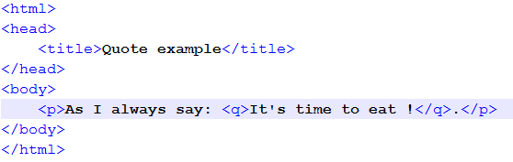

* The ……………….. tag specifies a section that is quoted from another source.
* Browsers usually indent <blockquote> elements.
* <blockquote> is called an **block element** because it cannot be put inside a line of text. A block element will create a line break to outside the current line.

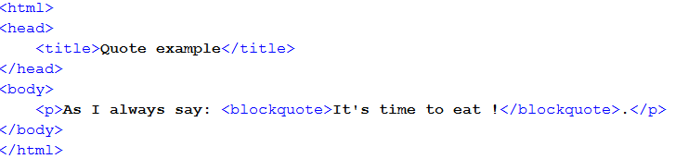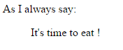

## INLINE AND BLOCK ELEMENTS

Most HTML elements are defined as block level elements or inline elements.

……………………………… normally start (and end) with a new line, when displayed in a browser.

Examples: ………………………………

……………………………… are normally displayed without line breaks.

Examples: …………………………………..

## NESTED ELEMENTS AND HTML TREE

HTML elements can be nested (elements can contain elements).

All HTML documents consist of nested HTML elements. This hierarchy can be represented in a tree

*In the below example, P and H1 are nested in BODY. BODY is nested in HTML*

<!DOCTYPE html>  
<html>  
  
<body>  
  <h1>My First Heading</h1>  
  <p>My first paragraph.</p>  
</body>  
  
</html>